Pre Laboratory Assignment- Conductors, Semiconductors, and Insulators

Please complete your pre-lab assignment in your lab notebook before coming to lab. You must include the following elements or your instructor will not allow you to enter the lab:
- Name, date, title course and section
- Safety data sheet
- Background and the “why”
- Procedure or “how”
- Data tables: Chemical Data Table (http://www.sigmaaldrich.com/united-states.html)

Chemical Data Table (http://www.sigmaaldrich.com/united-states.html)
Chemical Name | Chemical Formula | Safety Precautions | Disposal
Glass coverslips
Zinc metal
Silicon wafers

- The 3 pre-lab questions below – please write questions and answers in your notebook

- Briefly define the following terms:

Conductor:
Semiconductor:
Insulator:

- Briefly define what is meant by doping semiconductors. Briefly describe the difference between n-type and p-type doping of silicon in terms of doping agent and charge carriers.

- Explain what is meant by a diode.
Purpose:
In this laboratory you will be assembling several circuits using different conductors, semiconductors, and insulators as electrodes. Using the materials provided, you will determine which samples are conductors, semiconductors, and insulators. You will also explore the differences between various types and levels of doped silicon semiconductors using known and unknown samples.

Background:
Elements on the periodic table can be sorted based on their ability to conduct electricity. Metals tend to be good conductors, non-metals are poor conductors, and metalloids are often considered semi-conductors. The basis for the difference of conductivity of these materials can be considered in terms of how the electrons are organized in a pure solid sample of the element. In solids, atoms are closely packed, leading to overlapping molecular orbitals and bands of electrons (Figure 1). These large overlapping molecular orbitals create bands, a valence band and a higher energy conduction band. The energy difference between these two bands is known as the band gap energy (Figure 2) (Burdge 914-915, Kotz, Treichel, and Townsend 595-598).

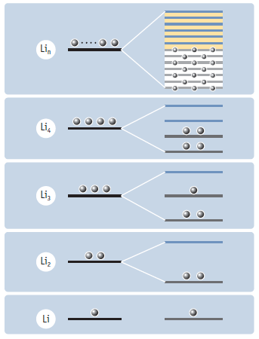
Figure 1: Schematic showing the band theory of molecular orbitals in metals. The 2s valence orbitals of Li atoms combine to form bonding and antibonding molecular orbitals. As more atoms are added to the solid sample, the number of molecular orbitals increase, until they form closely packed bands (Kotz, Treichel, and Townsend 597).

When there is a very small band gap energy, electrons can easily jump into the conduction band, where they are more delocalized and can move more freely. This allows the electrical current to be conducted across the sample. However, if there is a large band gap energy, electrons cannot move into the conduction band. In this case, the electrons cannot move freely and thus cannot conduct electricity. This explains one of the major difference between conductors, semi-conductors, and insulators. Conducting materials have a small band gap energy, insulators have a large band gap energy, and semiconductors are in between (Figure 2, Burdge 914-915).
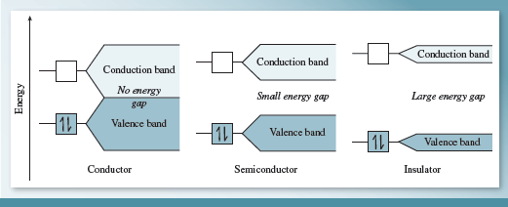
Figure 2: “Energy bands in metals (conductors), semiconductors, and insulators” (Burdge 1021).

Semiconductors have become useful in modern electronic systems, largely because they are normally not conductors, but can be manipulated to conduct electricity in given conditions. In temperatures elevated enough to excite the electrons to the conducting band, or when small amounts of specific elements are mixed with the semiconductors, these materials can conduct electricity. Adding these other elements to the semiconductors is called doping. Silicon, one of the most commonly used semiconductors, can be doped with Group IIIA (ex. B, Al) or Group VA (ex. P, Ga) elements. When silicon, a Group IV element is combined with these dopants, there is a bonding mismatch (Figure 3). Group IIIA elements only have 3 valence electrons, whereas silicon has 4 valence electrons. This means that there is a “hole” or an empty space where that last electron would form a bond with the 4th valence electron from silicon. Since there is an absence of an electron in this case, this type of doping is called p-type (or positive) doping. In the case of Group V element dopants, there is an “extra” electron. The first 4 valence electrons form bonds with the silicon valence electrons, but the 5th electron remains unbonded. This type of doping is called n-type (or negative), because of the extra negative charge. In p-type doping, the holes remain in the valence band, but spaces they represent create a method for more electron movement and conductivity when a current is applied to the sample. For n-type doping, an electrical current can remove the extra electron from the dopant so that the electron can move around in the lattice, allowing for conductivity (Figure 4). In this way, a very small amount of dopant can lead to a large increase in conductivity of the semiconductor (Burdge 914-915, 1021-1022).
Figure 3: (a) Silicon crystal doped with phosphorus. (b) Silicon crystal doped with boron. Note the formation of a negative center in (a) and a positive center in (b) (Burdge 915).

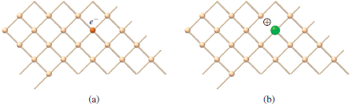

Figure 4: The effect of doping on conductivity of silicon (Kotz, Treichel, and Townsend 597).

A Schottky barrier is a potential energy barrier for electrons formed at a metal-semiconductor junction. Depending on the doping type (n-type versus p-type) and the doping level (density of doping atoms) of the semiconductor and the electronic properties of the metal, a Schottky barrier will form a diode. A diode is an electronic circuit element that primarily flows current in only one direction and blocks current from flowing in the opposite direction. Directing the flow of current has many different uses, including when generating light in light-emitting diodes (LEDs) (Kotz, Treichel, and Townsend 598).

In this lab, we will use a power source to control the amount of voltage (electrical potential) supplied to the electrodes. We will also use a multimeter to measure the amount of current (mAmp, flow of electrons) moving between the electrodes. It is the current that can expose which electrodes are more/less conductive.

Procedure:
Part I: Experimental SET-UP:
In this part of the lab you will be making a circuit using various materials. The energy source (a variable DC voltage source) will provide the electricity for the circuit and a multimeter will be added in series to monitor the amperage of the circuit. Wires will be used to connect the source and multimeter to the electrodes. One electrode will always be a conductive metal. However, the other electrode will vary in each part of the lab. In this part of the lab, you will be setting up the experiment according to the image shown in Figure 5. For now, attach the metal to the 1st electrode place (positive electrical bias) and keep the 2nd electrode place (negative electrical bias) empty and make sure the power source is off.

Safety issues: To reduce the chance of accident shocks, make sure that the electrodes never touch and that the alligator clips for each electrode don’t touch until you are ready. Keep the energy source turned off until just before you test the electrodes. Do not exceed 10V. Make sure to handle glass, metal, and silicon wafers with caution – the edges can be sharp. Wear gloves to avoid cuts and to avoid fingerprints.

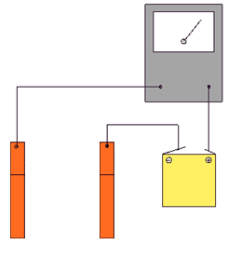

⊝
⊕

connectingwire
Figure 5: Basic schematic of the circuit. Yellow: the energy source, Grey: the multimeter, Black: the wires, Orange: the electrodes (one will always be a conductive metal and the other one will vary). Image edited from: http://www.funsci.com/fun3_en/electro/elec_02.gif

red wire
#2
#1
black wire
Instructions on how to use the multimeter (specific for this model)

Measuring current. Current will be measured in milliamperes
- For the metal-metal experiment, set the multimeter dial to the highest amp scale (150 DC mA, where 1 mA = 1 milliamp)
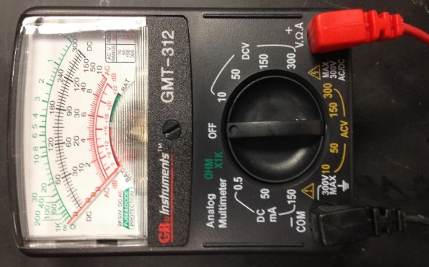
- Using the black scale from 0 to 150 (first row), read the current measurement.
- For all the rest of the experiments, set the multimeter dial to the lowest amp scale (0.5 DC mA, where 1 mA = 1 milliamp)
- Using the black scale from 0 to 50 (second row), read the current measurement.
- Divide your measurement by 100 to convert your current value to mA.
- If, when using the highly doped Si, your measurement goes out of scale (over 50), set the multimeter to the 50 mA scale.
- Using the black scale from 0 to 50 (same row as before), read the current measurement. That value will result in a current measurement in milliamperes (there is no need to divide by 100).

Part II: circuit with known electrodes
- Making sure that a metal electrode is already on the 1st electrode (positive bias), connect the metal sample as the 2nd electrode. Set the power source to 1V (record the exact setting) and use the multimeter (set to 150 DC mA) to determine the amperage. It should read 0 if the electrodes are still not touching.
- Then, carefully touch the two metal electrodes to each other. Record the voltage from the power source, the maximum amperage observed on the meter (you will see swings in amperage based on the strength of the connection), and observations. Make sure only the electrodes are touching and not the metal from the alligator clips.
- If multimeter doesn’t show an amperage reading, separate the electrodes, change the power source to 2V and then try again. Continue slowly testing increases in voltage (1 V at a time) until you get to a maximum of 10V. Due to background noise in the multimeter, a minimum of 0.10mA is needed to stop increasing voltage.
- Turn the multimeter to the 0.5 DCmA setting and repeat this procedure for all the following:
  - The glass coverslip
  - Each of the silicon wafers (1 undoped sample, 1 highly doped sample, 2 medium doped samples (1 p-type and 1 n-type)).
- Notes: If possible, touch the shiny side to the metal, not the dull side. If the amperage is off the scale, turn the meter to the higher DC mA settings. You might need to change the metal to the black wire (negative bias, electrode #2) and the medium doped p-type Si to the red wire (positive bias, electrode #1) when you do this sample. You also might want to check the impact of changing the electrodes for the n-type Si.

Part III: circuit with unknown electrode
- Connect the first unknown sample as the 2nd electrode and use the multimeter to determine the volts and amperage of the circuit. Make sure to record these numbers and also observations.
- Using the voltage and amperage data, determine if your unknown is a conductor, insulator or semiconductor.
- If your sample is a semiconductor, determine if it has
  - No doping, high doping, or medium doping
  - p-type or n-type doping if medium-doped Si.

CALCULATIONS AND DISCUSSION:
- Create a summary table of all of data for Parts II and III (see example below).
- In your notebook, explain how you made your determination of the identity of your unknown.

Example summary table:

Sample on positive (electrode #1) | Sample on negative (electrode #2) | Voltage applied (V) | Amperage reading (mA)
Zn | glass | 1.0 | 0.00
Zn | glass | 2.0 | 0.00
CHE 102 Conductors, Semiconductors, and Insulators Lab – Checklist
Your lab report must include each of the following components. If you don’t bring a complete pre-lab or appropriate safety gear with you at the start of lab, you will not be allowed to perform the lab.

-----------------------------------------------Prepared BEFORE the lab-----------------------------------------
1. REPORT HEADING
􀀀 Includes full name, partner’s name, drawer #, date, section #, and title of the lab

2. INTRODUCTION
􀀀 Background and “why”: general purpose or problem under investigation
􀀀 Procedure or “how”: summary general procedural approach
􀀀 Any important balanced equations and mathematical equations (N/A)
􀀀 Safety table

3. PRE LAB QUESTIONS
􀀀 All three pre lab questions completed

-----------------------------------------------Prepared DURING the lab-----------------------------------------

4. LABORATORY JOURNAL
􀀀 Detailed procedure, including samples/equipment used for all parts.
􀀀 Data table for voltage setting, amperage reading and sample used
􀀀 Data tables contain correct significant figures and units
􀀀 Detailed observations
􀀀 Description of how unknown was determined

5. CALCULATIONS
􀀀 N/A

6. LAB SKILLS
􀀀 Correct use of multimeter

7. CONCLUSION
􀀀 Summarize your background: Statement of general purpose
􀀀 Briefly summarize your procedure: Statement of general procedural approach
􀀀 Summary of results
􀀀 Includes at least 2 possible sources of scientific or procedural error
􀀀 Modifications to minimize errors in future or other recommendations for further experiments

DEDUCTIONS
􀀀 Not organized properly according to The Anatomy of a Lab Report
􀀀 Illegible handwriting
􀀀 Not generally acceptable spelling and grammar
􀀀 Station(s) not cleaned post-lab, including any area of the lab
􀀀 Using pencil/colored pen (use black or blue pen)
􀀀 Not your own words
􀀀 Contains scribbles or cross-outs that are not single-line

